UNIT II
BIPOLAR JUNCTION TRANSISTORS (BJT)
BJT
- Beside diodes, the most popular semiconductor devices is transistors. Eg: Bipolar Junction Transistor (BJT).
- Few most important applications of transistor are: as an amplifier and as a switch.
- Transistor is a three terminal device namely Base, emitter and collector.
- In bipolar transistor the current conduction is due to both the types of charge carriers, namely holes and electrons. Hence this is called Bipolar Junction Transistor (BJT).
- In BJT the output current is controlled by input current and hence it is a current controlled device.
Type of BJT
- NPN Transistor
- PNP Transistor
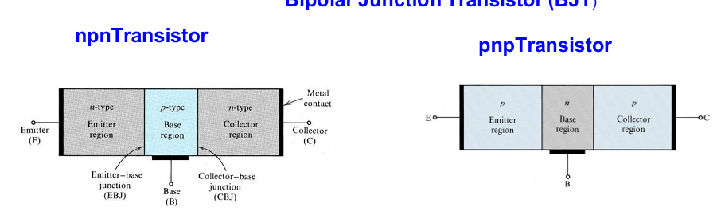
- BJT is a 3terminaldevice. namely- emitter, base and collector.
- NPN transistor: emitter & collector are n-doped and base is p-doped.
- Emitter is heavily doped, collector is moderately doped and base is lightly doped and base is very thin.
Mode of operation for BJT
- In order to operate transistor properly as an amplifier, it is necessary to correctly bias the two p-n junctions with external voltages.
- Depending upon external bias voltage polarities used, the transistor works in one of the three regions, Active region, Cut-off region and Saturation region.
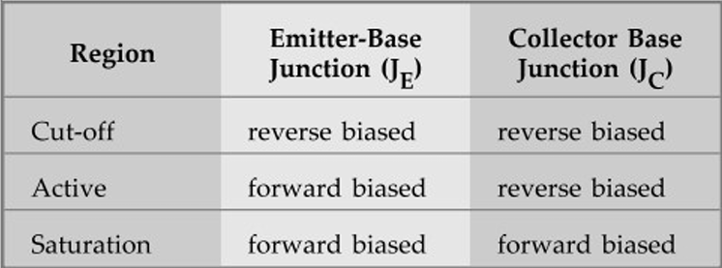
Working Principles of NPN Transistor
- The Emitter-Base (EB) junction is forward bias and Collector-Base (CB) is reversed bias.
- The forward biased EB junction causes the electrons in the n-type emitter to flow towards the base. This constitutes the emitter current I_{E}.
- As these electrons flow through the p-type base, they tend to combine with holes in p-region (base). Due to light doping, very few of the electrons injected into the base from the emitter recombine with holes to constitute base current, I_{B}.
- The remaining large number of electrons cross the base region and move through the collector region to the positive terminal of the external d.c source. This constitutes collector current I_{C}.
- Since, most of the electrons from emitter flow in the collector circuit and very few combine with holes in the base. Thus, the collector current is larger than the base current.
I_{E} = I_{B} + I_{C}

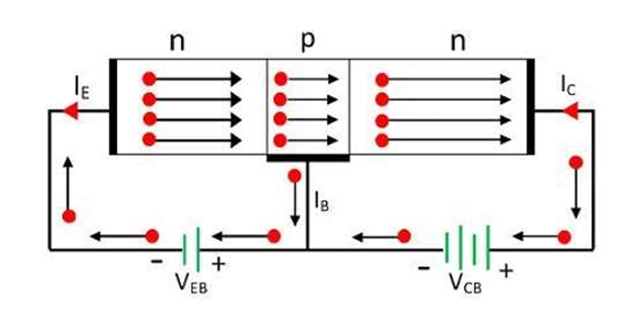
Working Principles of PNP Transistor
- The forward biased EB junction causes the holes in the p-type emitter to flow towards the base. This constitutes the emitter current I_{E}.
- As these holes flow through the n-type base, they tend to combine with electrons in n-region(base). Since, the base is very thin and lightly doped, very few of the holes injected into the base from the emitter recombine with electrons to constitute base current, I_{B}.
- The remaining large number of holes crosses the depletion region and move through the collector region to the negative terminal of the external DC source. This constitutes collector current I_{C}.
- Thus, the hole flow constitutes the dominant current in an PNP transistor. Since, most of the holes from emitter flow in the collector circuit and very few combine with electrons in the base. Thus, the collector current is larger than the base current.
I_{E} = I_{B} + I_{C}
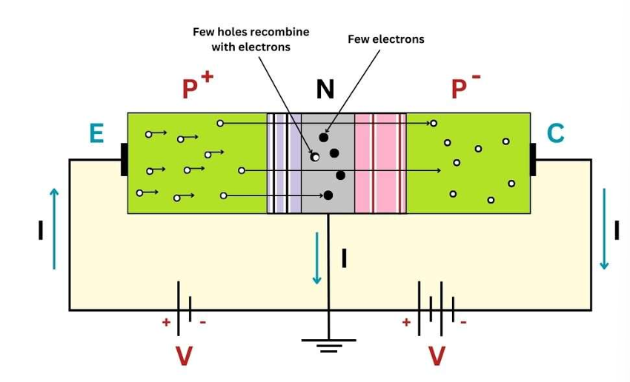
Different Configuration of BJT
Common Base Connection (CB) Configuration
- Base is common to input and output
- High voltage gain, low input impedance, no current gain
- Used in high-frequency applications
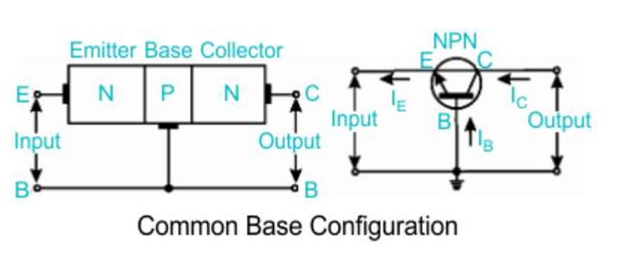
Common Emitter (CE) Configuration
- Emitter is common to input and output
- High voltage and current gain
- Most widely used for amplification
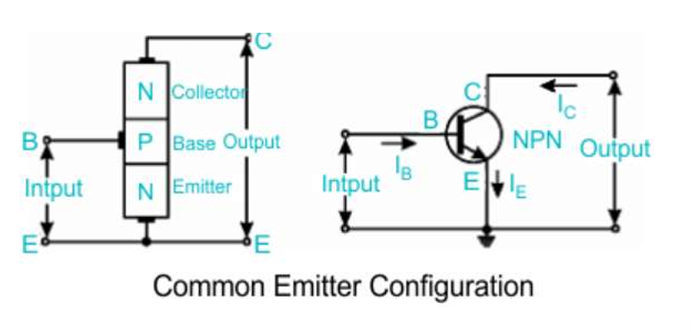
Common Collector Configuration (CC) also called Emitter Follower
- Collector is common to input and output
- High input impedance, low output impedance, unity voltage gain
- Used for impedance matching
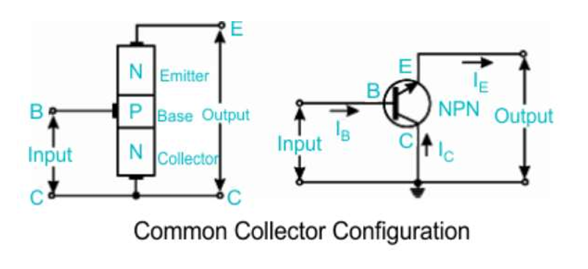

Input and Output Characteristics Common Base Configuration
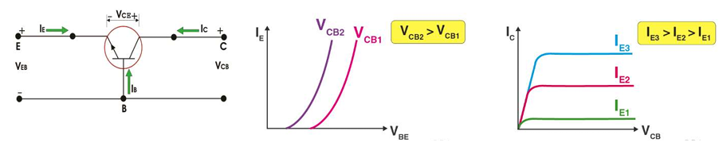
- In CB Configuration, the Base terminal of the transistor will be connected common between the output and the input terminals.
- Input Characteristics: The variation of emitter current (I_{E}) with Base-Emitter Voltage (V_{BE}), Keeping Collector Base Voltage (V_{CB}) constant.
- Output Characteristics: The Variation of Collector current (I_{C}) with Collector-Base voltage (V_{CB}), keeping the emitter current (I_{E}) constant.
- Input Characteristics of CB Configuration
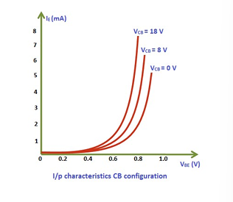
- The input characteristics of a BJT in common base configuration represent the relationship between the emitter current and the emitter–base voltage while keeping the collector–base voltage constant.
- Since the emitter–base junction is forward biased, an increase in emitter–base voltage reduces the barrier potential of the junction and allows more charge carriers to flow from the emitter into the base region.
- As a result, the emitter current increases rapidly with a small increase in emitter–base voltage.
- The input characteristic curve therefore resembles the forward bias characteristic of a PN junction diode.
Base Width Modulation (or) Early Effect
- When reverse bias voltage VCB increases, the width of depletion region also increases, which reduces the electrical base width.
- This reduces recombination in the base region, and hence a slightly smaller emitter–base voltage is required to produce the same emitter current.
- Due to this reason, the input characteristics shift slightly with changes in collector–base voltage.
- Output Characteristics of CB Configuration
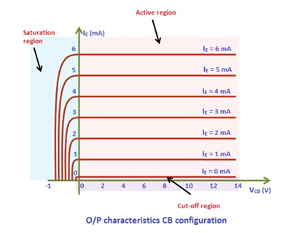
- The curve may be divided into three important regions namely saturation, active and cut off region.
- Active Region
- The active region is the region between the vertical dashed line and the horizontal axis.
- In the active region, the collector current is constant and is equal to the emitter current.
- Saturation Region
- The saturation region is the region to the left of the vertical dashed line.
- It may be noted that in this region, collector to base voltage (VCB) is negative for a NPN transistor.
- In this region, a small change in VCB results in a large value of collector current.
- Cut off Region
- The cut off region is the region along the horizontal axis as shown by a shaded region in the figure.
- It corresponds to the curve marked IE = 0.
- The collector current flows even when the collector to base voltage (VCB) is zero. A small collector current flows even when emitter current (IE) is zero.
- Current Relation in Common Base Configuration
- In common base configuration, the current transfer mode ratio (α) of a bipolar transistor in the forward active mode is defined as the ratio of the collector current (I_{C}) to the emitter current (I_{E}):
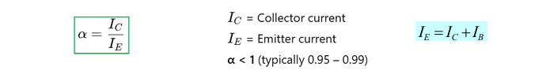
- Leakage current: It is the small unwanted current that flows in a transistor even when the input junction is not forward biased, mainly due to minority carriers and it increases with temperature.
- Leakage current:
- I_{CBO} = Collector–Base leakage current.
- Flows when emitter is open and CB junction is reverse bias.
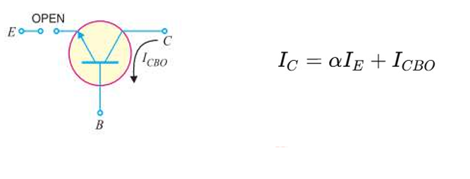
- When I_{E} = 0, I_{C} = I_{CBO} is the current caused by the minority carriers crossing the pn-junction.
- I_{CBO} is leakage current called as collector base current with emitter open.

Input and Output Characteristics Common Emitter Configuration
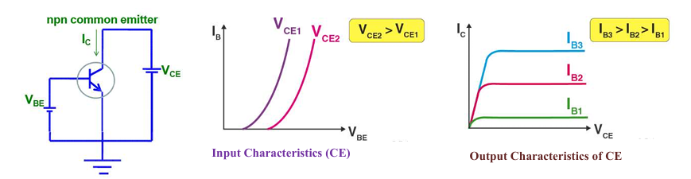
- In CE Configuration, the Emitter terminal of the transistor will be connected common between the output and the input terminals.
- Input Characteristics (CE): The input characteristics of a CB transistor are the plot of base current (I_{B}) versus emitter–base voltage (V_{EB}) at a constant collector–emitter voltage (V_{CE}).
- Output Characteristics (CE): The output characteristics of a CB transistor are the plot of collector current (I_{C}) versus collector–emitter voltage (V_{CE}) a constant collector current (I_{C}).
- Input Characteristics of BJT in Comon Emitter Configuration
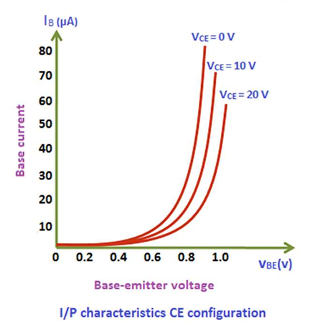
- The input characteristics of a BJT in common emitter configuration describe the relationship between the base current and the base–emitter voltage while keeping the collector–emitter voltage constant.
- In the common emitter configuration, the base emitter junction is forward biased, and therefore a small increase in the base–emitter voltage causes a significant increase in the base current.
- Due to this forward biasing, the input characteristic curve resembles that of a forward-biased PN junction diode.
- When the collector–emitter voltage is increased, the reverse bias across the collector–base junction increases, which reduces the effective base width due to the Early effect.
- As a result, for the same base current, a slightly smaller base–emitter voltage is required, causing a slight shift in the input characteristic curves.
- Output Characteristics of BJT in Comon Emitter Configuration
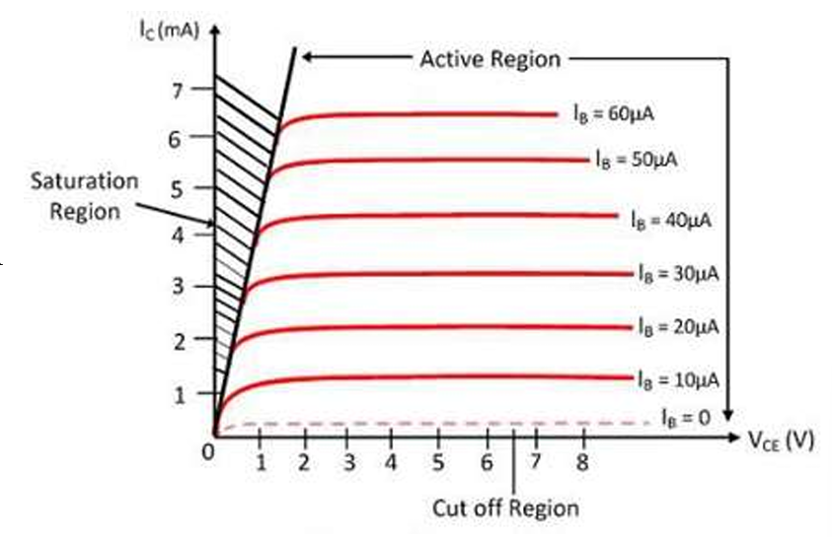
- The output characteristics of a BJT in common emitter configuration represent the relationship between the collector current and the collector–emitter voltage for a constant value of base current.
- In the active region of operation, the base–emitter junction is forward biased and the collector–base junction is reverse biased, and under these conditions, the collector current remains almost constant for a wide range of collector emitter voltages.
- The collector current mainly depends on the base current and is approximately equal to the product of the base current and the current gain beta.
- At very low values of collector–emitter voltage, both junctions become forward biased and the transistor operates in the saturation region, where the collector current increases rapidly with voltage.
- When the base current is zero, the transistor operates in the cutoff region and only a small leakage current flows through the collector.
- Current Gain in Common Emitter Configuration
- Current gain β (beta) is the ratio of collector current to base current in a common emitter (CE) configuration.
- Collector–Emitter Leakage Current
It is the collector–emitter leakage current that flows when the base is open and the collector–base junction is reverse biased (CE configuration).
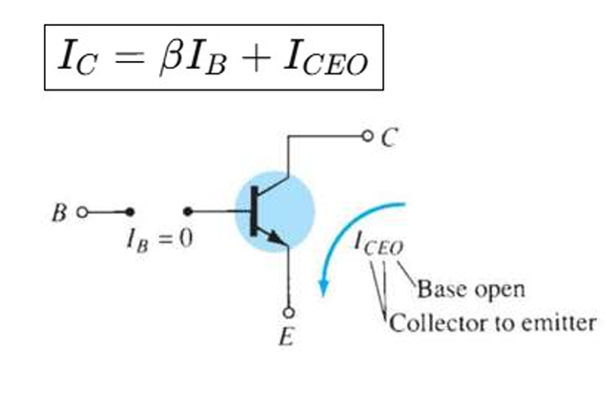
- Relation between I_{CBO} and I_{CEO}
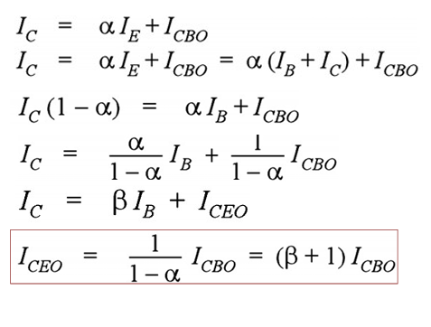
- Relation between current gain α and β
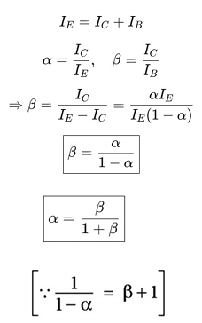
- Common Collector Configuration
- In CC Configuration, the Collector terminal of the transistor will be connected common between the output and the input terminals.
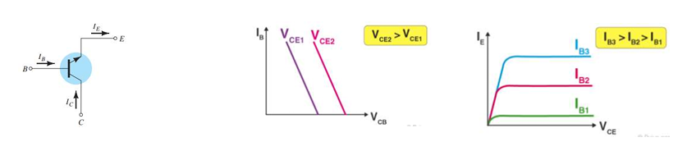
- Input Characteristics: The Variation of emitter current (I_{B}) with Collector-Base voltage (V_{CB}), keeping Collector Emitter Voltage (V_{CE}) constant.
Output Characteristics: The variation of emitter current (I_{E}) with Collector-Emitter voltage (V_{CE}) keeping the base current (I_{B}) constant.
BJT Biasing
- The analysis or design of a transistor amplifier requires a knowledge of both the dc and the ac response of the system.
- The analysis or design of any electronic amplifier has two components: a dc and an ac portion.
- Transistor Biasing is the process of setting a transistors DC operating voltage or current conditions to the correct level so that any AC input signal can be amplified correctly by the transistor.
- For the BJT to be biased in its linear or active operating region: The base–emitter junction must be forward-biased and base–collector junction must be reverse-biased.
- The types of transistor biasing include:
  - Fixed Bias
  - Emitter Bias
  - Voltage Divider Bias
  - Collector Feedback Bias
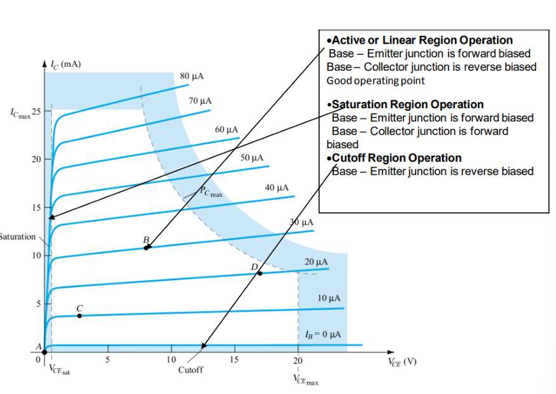
- Fixed Bias Method
  - In the fixed bias method, a resistor is connected between the base and the DC supply to provide the required base current.
  - The base–emitter junction is forward biased by the base supply, and the collector–emitter circuit is powered by a separate supply.
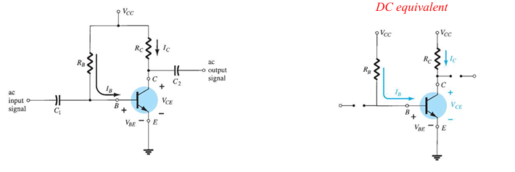
Applying KVL to the base–emitter circuit loop
+ V_{CC} - I_{B}R_{B} – V_{BE} = 0
Solving the equation for the current I_{B} results in the following:
I_{B} = $\frac{Vcc-Vbe}{Rb}$
The Collector Current can be calculated from base current:
I_{C} = βI_{B}
Apply KVL to collector – Emitter Loop
V_{CE} + I_{C}R_{C} – V_{CC} = 0
V_{CE} = V_{CC} – I_{C}R_{C}
where V_{CE} is the voltage from collector to emitter and V_{C} and V_{E} are the voltages from collector and emitter to ground, respectively. In this case, since V_{E} = 0 V, we have
V_{CE} = V_{C}
V_{BE} = V_{B} - V_{E} and V_{E} = 0 V, then
V_{BE} = V_{B}
- Load – Line Analysis
  - Load line analysis is a graphical method used to determine the operating point or Q-point of a transistor on its output characteristics.
  - It shows all possible combinations of collector current and collector–emitter voltage for a given power supply and load resistance.
  - The load line helps in selecting a proper operating point so that the transistor remains in the active region during signal amplification.
V_{CE} = V_{CC} – I_{C}R_{C}
By substituting I_{C} = 0 mA we find that
V_{CE} = V_{CC} |I_{C} = 0 mA
  - I_{C} is determined by substituting V_{CE} = 0
  - The point where the DC load line intersects the transistor output characteristic corresponding to a particular base current is called the operating point or Q-point.
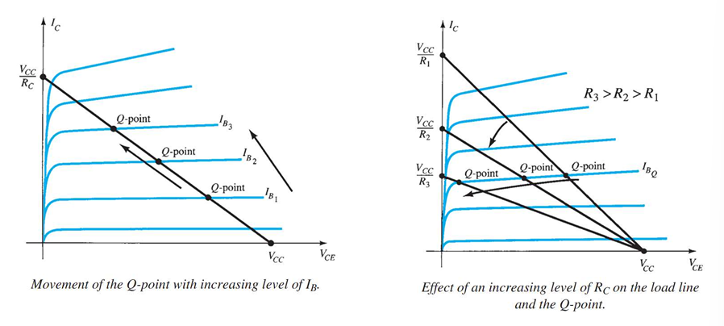
Emitter Bias Method
- In fixed bias method is simple and easy to analyse, but it provides poor stability because the collector current depends heavily on the transistor’s beta.
- A small change in beta or temperature can cause a large change in collector current, which may shift the operating point out of the active region.
- In the emitter bias method, an emitter resistor is added to improve stability. The voltage drop across the emitter resistor increases with an increase in emitter current, which in turn reduces the base–emitter voltage.
- Base – Emitter Loop
Applying KVL to the base-emitter circuit loop
+V_{CC} – I_{B}R_{B} – V_{BE} – I_{E}R_{E} = 0
We know that the relation between base and emitter current is
I_{E} = ($β$ + 1) I_{B}
Substituting for I_{E}, we get
V_{CC} – I_{B}R_{B} – V_{BE} – ($β$ + 1) I_{B}R_{E} = 0
Solving for I_{B} gives
$IB= \frac{VCC-VBE}{RB+\left(β+1\right)RE}$
- Collector – Emitter Loop
Applying KVL to the collector–emitter circuit loop
V_{CC} – I_{C}R_{C} – V_{CE} – I_{E}R_{E} = 0
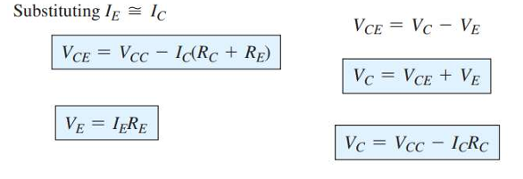
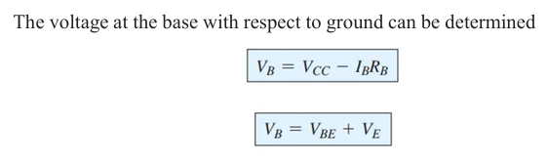

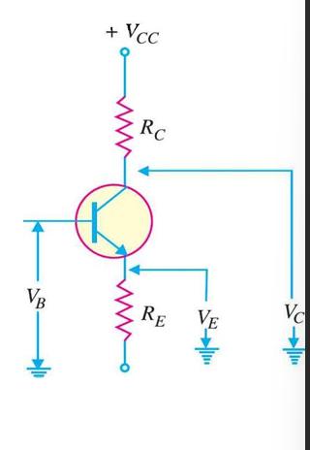
Load – Line Analysis of Emitter Bias
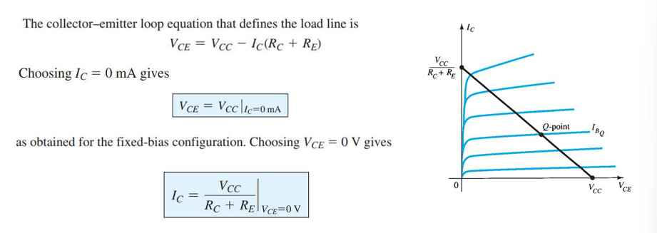
The addition of the emitter resistor to the dc bias of the BJT provides improved stability, that is, the dc bias currents and voltages remain closer to where they were set by the circuit when outside conditions, such as temperature and transistor beta, change.
Voltage Divider Bias
In the previous bias configurations, the Q-points were dependent on β which is temperature sensitive. Voltage divide bias arrangement reduces the dependency of β.
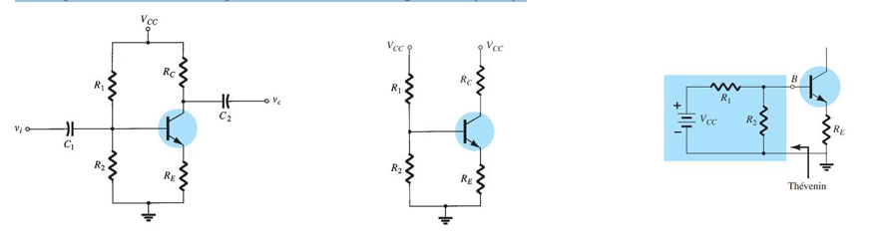
Applying Thevenin equivalent network for the network to the left of the base terminal as RTh The voltage source is replaced by a short-circuit equivalent as shown in Fig.
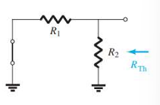
R_{th} = R₁ || R₂

Junction Field Effect Transistor (JFET)
Introduction to field effect transistor
- A field effect transistor is a voltage – controlled device i.e. the output characteristics of the device are controlled by input voltage. There are two basic types of field effect transistors:
  - Junction field effect Transistor (JFET)
  - Metal oxide semiconductor field effect transistor (MOSFET)
Junction Field Effect Transistor (JFET)
- A JFET is a three terminal semiconductor device in which current conduction is by one type of carrier i.e. electrons or holes.
- It has three terminals namely Source (S), Drain (D) and Gate (G).
- The current conduction is controlled by means of an electric field between the gate and the conducting channel of the device.
- There are two types of JFET’s namely N-channel JFET’s and P-channel JFET’s.
- Generally N-channel JFETs are more preferred than P-channel.
Construction of JFET
- In an N-channel JFET an N-type silicon bar, referred to as the channel, has two smaller pieces of P-type silicon material diffused on the opposite sides of its middle part, forming P- N junctions.
- The two P-N junctions forming diodes or gates are connected internally and a common terminal, called the gate terminal, is brought out.
- Ohmic contacts (direct electrical connections) are made at the two ends of the channel— one lead is called the Source terminal S and the other Drain terminal D.
  - Source–The terminal through which the majority carriers enter the channel, is called the source terminal S.
  - Drain– The terminal, through which the majority carriers leave the channel, is called the drain terminal D
  - Channel–The region between the source and drain, sandwiched between the two gates is called the channel and the majority carriers move from source to drain through this channel.
- The gate terminal is used to control the flow of current from source to drain. In the figure above, the gate is P-region, while the source and the drain are N-regions.

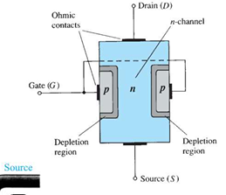
Working Principle of JFET
- Fig. shows the n-channel JFET polarities in which the voltage between the gate and source is such that the gate is reverse biased.
- When a voltage V_{DD} is applied between drain and source terminals and voltage on the gate is zero as shown in fig., then two P-N junctions at the sides of the bar establish depletion layers.
- The electrons will flow from source to drain through a channel between the depletion layers.
- The size of the depletion layers determines the width of the channel and hence current conduction through the bar.
- For small applied voltage V_{DD}, the n-type bar acts as a simple semiconductor resistor and the drain current increases linearly with the increase in V_{DD}, up to the knee point. So, with the increase in V_{DD}, the conducting portion of the channel begins to constrict more at the drain end. Eventually a voltage reached at which the channel is pinched off.
- The drain currents I_{D} no longer increases with the increase in V_{DS}. It approaches a constant saturation value. The drain current in the pinch-off region with V current (I DSS GS = 0 is referred to the drain-source saturation).
- Drain current in the pinch-of region is given by Shockley’s equation
I_{D} = I_{DSS} ${(1-\frac{Vgs}{Vp})}^{2}$
Pinch-off voltage
The value of voltage V_{DS} at which the channel is pinched off (i.e. all the free charges from the channel get removed) and the drain current I_{D} attains a constant value is called as pinch off voltage V_{P}.
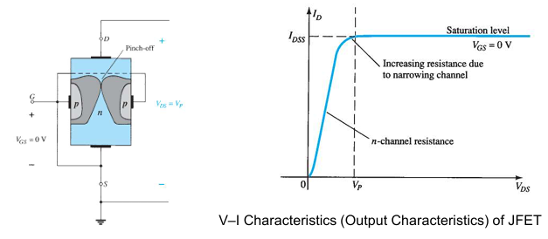
- When a reverse voltage V_{GS} is applied between gate and source terminals, then width of depletion layer is increased.
- This reduces the width of conducting channel, thereby increasing the resistance of n-type bar. Consequently, the current from source to drain is decreased.
- On the other hand, when the reverse bias on the gate is decreased, the width of the depletion layer also decreases.
- This increases the width of the conducting channel and hence source to drain current is increased.
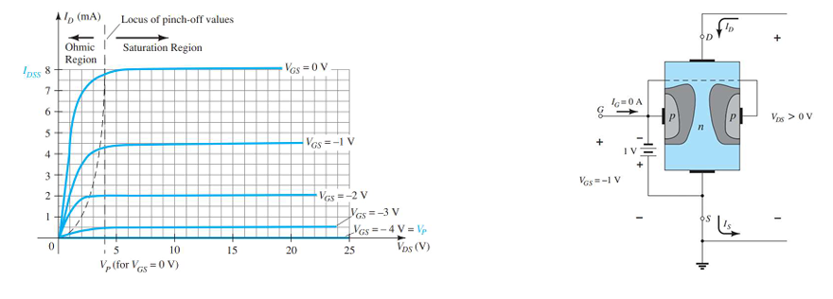
Transfer Characteristics of JFET
For the BJT transistor the output current I_{C} and the input controlling current I_{B} are related by beta, which was considered constant for the analysis to be performed. In equation form,
I_{C} = f(I_{B}) = βI_{B}
The relationship between ID and VGS is defined by Shockley’s equation
